
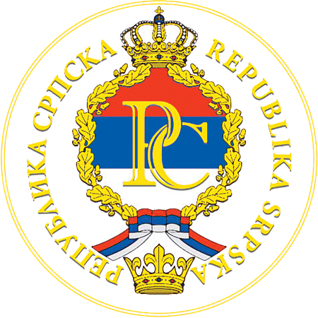

Characterization and Engineering
of Karst Aquifers
Trebinje, Bosnia & Herzegovina, 1 June – 8 June, 2017

PRELIMINARY APPLICATION FORM

Express of Interest

Name and surname

Title / Grade
Institution/Company/School
Brief applicant background

Address
City, State, ZIP

Tel./Fax no.

E-mail

Please return to:
Prof. Dr Zoran Stevanovic
Head of the Centre for Karst Hydrogeology
University of Belgrade - Faculty of Mining and Geology
Djusina 7, Belgrade 11000, Serbia
e-mails: zstev_2000@yahoo.co.uk ; veljko.marinovic@yahoo.com
fax :+381.11.3241557

For information on accommodation and booking please contact: hotelviv@gmail.com

